**EXPLORATORY DATA ANALYSIS ON DAY AHEAD MARKET PRICES**

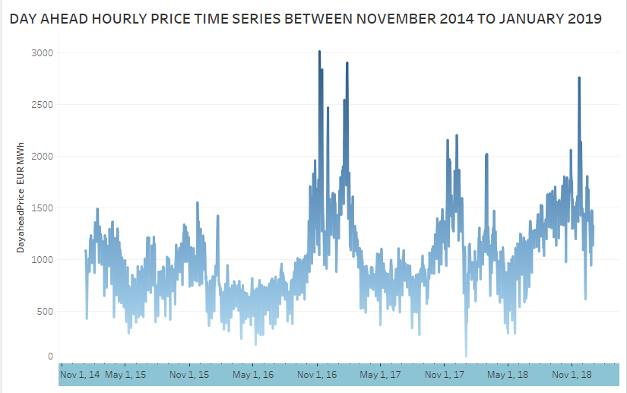

The above figure depicts the hourly price time series of the DA market, considering the period under study. The blue shaded between 7 November 2016 and 25 January 2017, which exhibited the highest prices during this four-year period. When applying statistical learning methods heavily dependent on the availability of suffic`ient historical data with high (or low) price regimes, it is expected that periods like this one will pose a challenge due to the non-existence of historical similarity.